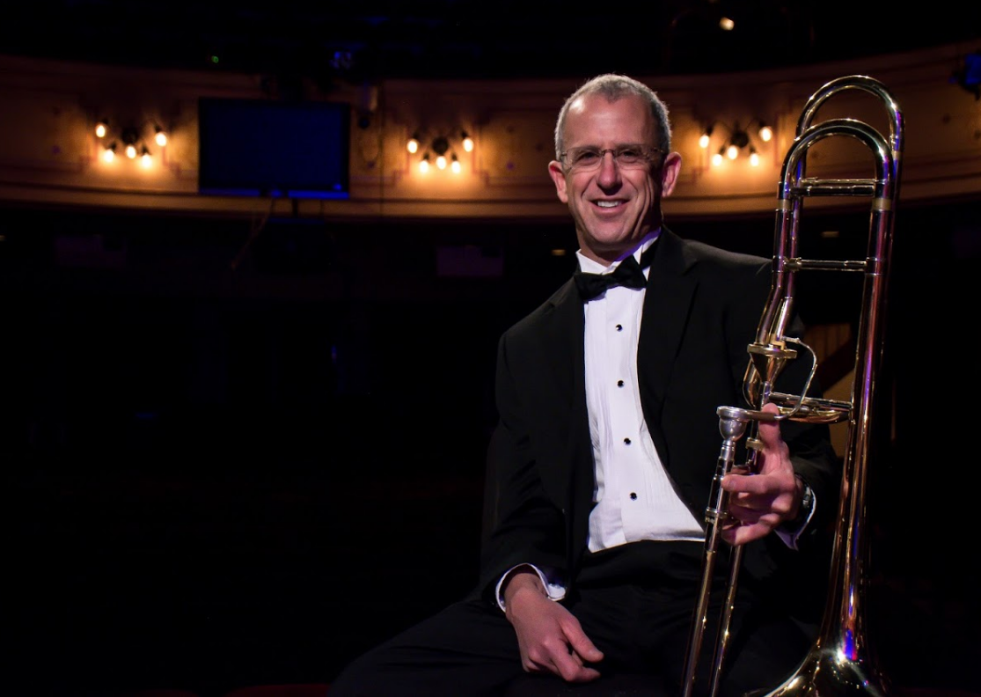

BRUCE ALPERN

Solo Trombone
Bruce Alpern rejoined the Sheldon Theatre Brass Band in 2004, having also played with us from 1992-97. He served as a musician in the Army for ten years and in National Guard for thirteen years, retiring last September. Bruce has been a mailman since 1992. He also plays with the Minnesota Jazz Orchestra.

